# 

## **How to Register on DSE:**

1. Visit the following link: <https://brandeis.dserec.com/online/clubsports_widget>
2. Under the Crew section, click “Registration”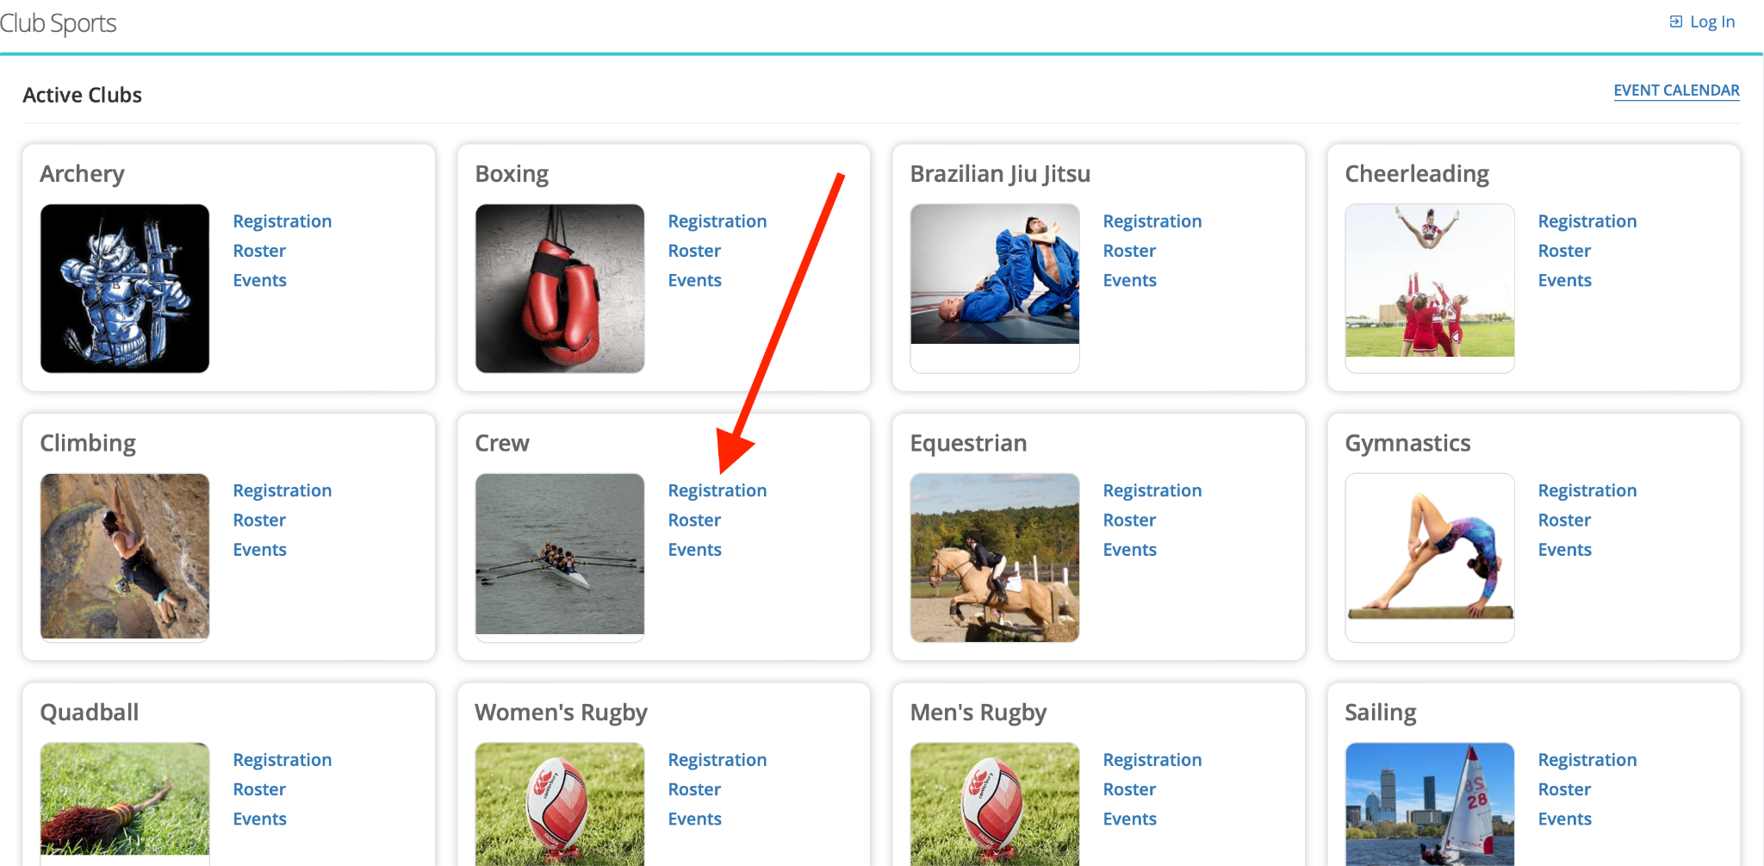
3. Sign in with your Brandeis credentials
4. Complete required information on “Personal Info” and “Additional Info” tabs
5. On the Risk & Conduct tab, sign by checking off each agreement

**\*\*\*THE HAZING AGREEMENT REQUIRES YOU TO CLICK THE “here” LINK IN ORDER FOR YOUR REGISTRATION TO BE APPROVED*** 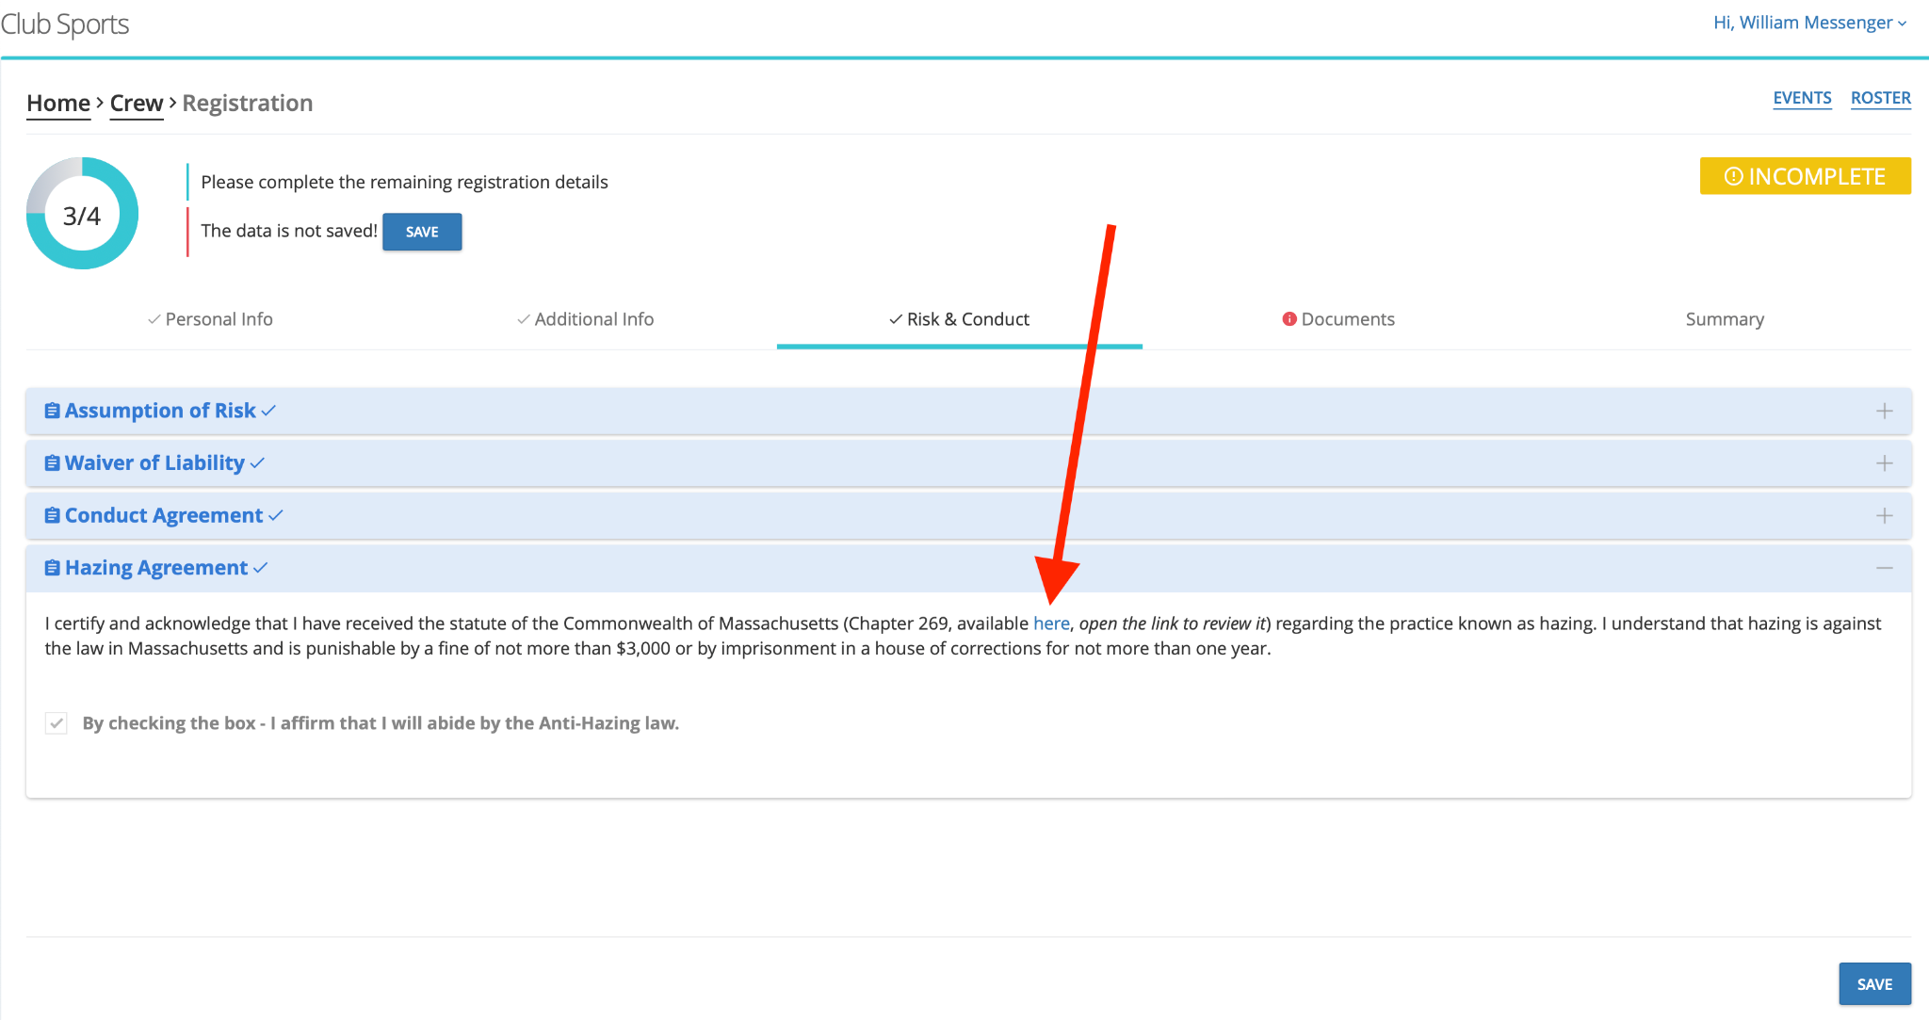**

1. Complete the remaining tabs to submit your registration